Bank Database — ACID Properties & Transaction Isolation SQL PRACTICAL / LAB EXERCISE
Name: CH.Srihitha
Roll No: 2520030400
Section: 7

Step 1 — Create Database
CREATE DATABASE Bank_ACID_DB;
USE Bank_ACID_DB;

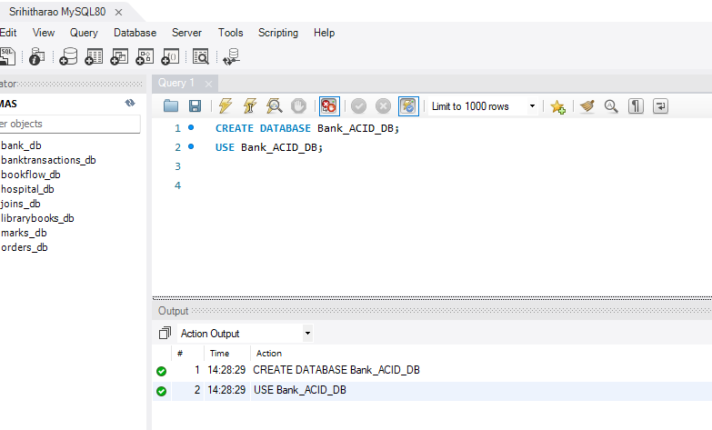

Step 2 — Create Customer Table
CREATE TABLE Customer (
Customer_ID INT PRIMARY KEY,
Customer_Name VARCHAR(100) NOT NULL,
Phone VARCHAR(15),
City VARCHAR(50)
);

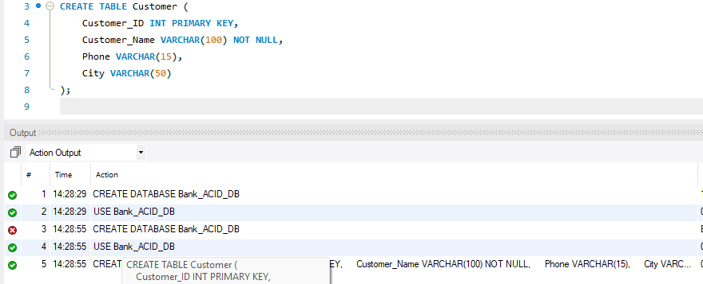

\Step 3 Create Account Table (FOREIGN KEY)
CREATE TABLE Account (
Account_No INT PRIMARY KEY,
Customer_ID INT,
Account_Type VARCHAR(20),
Balance DECIMAL(12,2),
Branch VARCHAR(50),
FOREIGN KEY (Customer_ID) REFERENCES Customer(Customer_ID) );

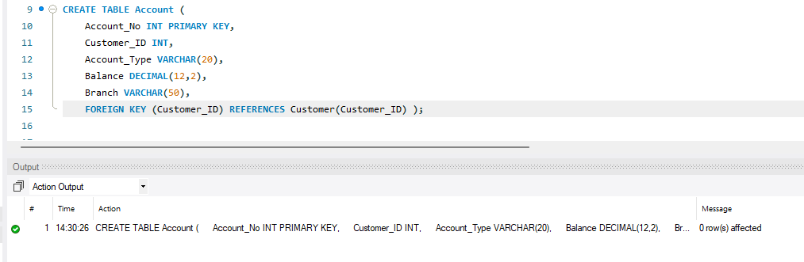

Step 4 — Insert Customer & Account Data, Then Display
INSERT INTO Customer (Customer_ID, Customer_Name, Phone, City) VALUES
(101, 'Hansika Reddy', '9876543210', 'Hyderabad'),
(102, 'Priya Sharma', '9876543211', 'Vijayawada'),
(103, 'Arjun Reddy', '9876543212', 'Bangalore'),
(104, 'Sneha Rao', '9876543213', 'Chennai'),
(105, 'Kiran Kumar', '9876543214', 'Hyderabad');

INSERT INTO Account (Account_No, Customer_ID, Account_Type, Balance, Branch) VALUES
(10001, 101, 'Savings', 50000, 'Hyderabad'),
(10002, 102, 'Savings', 75000, 'Vijayawada'),
(10003, 103, 'Current', 120000, 'Bangalore'),
(10004, 104, 'Savings', 45000, 'Chennai'),
(10005, 105, 'Current', 90000, 'Hyderabad');

SELECT * FROM Customer;
SELECT * FROM Account;

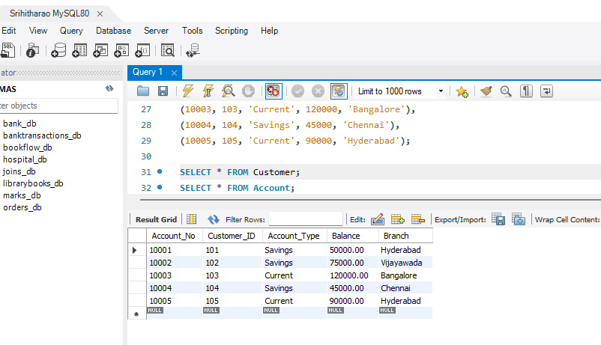

Step 5 — Deposit Transaction (COMMIT)
START TRANSACTION;

UPDATE Account
SET Balance = Balance + 5000
WHERE Account_No = 10001;

SELECT * FROM Account WHERE Account_No = 10001;

COMMIT;

SELECT * FROM Account WHERE Account_No = 10001;

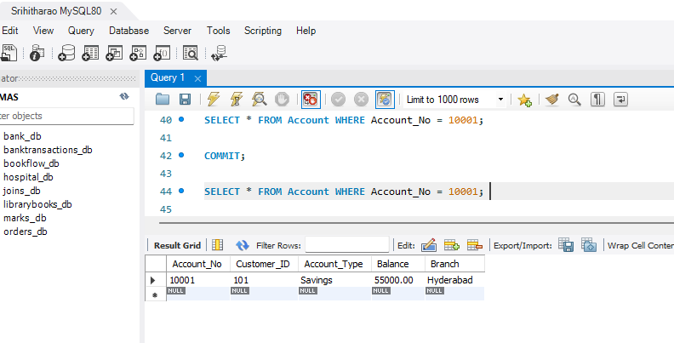

Step 6 Withdraw Transaction (ROLLBACK)
START TRANSACTION;

UPDATE Account
SET Balance = Balance - 10000
WHERE Account_No = 10001;

SELECT * FROM Account WHERE Account_No = 10001;

ROLLBACK;

SELECT * FROM Account WHERE Account_No = 10001;

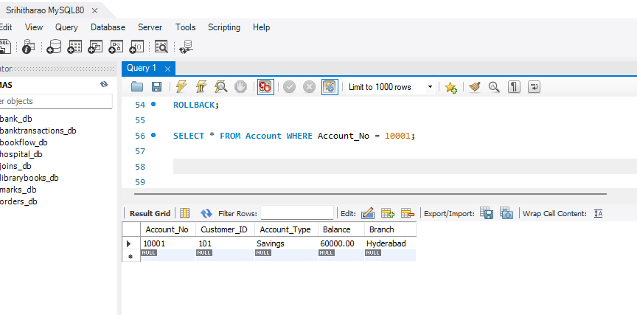

Step 7 — SAVEPOINT Demonstration
START TRANSACTION;

UPDATE Account SET Balance = Balance + 5000 WHERE Account_No = 10001;

SAVEPOINT Deposit1;

UPDATE Account SET Balance = Balance - 3000 WHERE Account_No = 10002;

SAVEPOINT Withdrawal1;

UPDATE Account SET Balance = Balance + 10000 WHERE Account_No = 10003;

ROLLBACK TO SAVEPOINT Withdrawal1;

COMMIT;

SELECT * FROM Account;

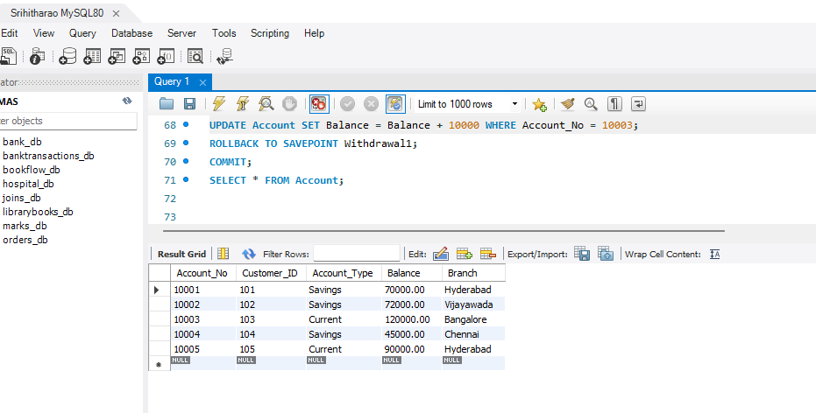

Step 8 — Bank Transfer (Demonstrates ATOMICITY)
START TRANSACTION;

UPDATE Account SET Balance = Balance - 10000 WHERE Account_No = 10001;

UPDATE Account SET Balance = Balance + 10000 WHERE Account_No = 10002;

SELECT * FROM Account WHERE Account_No IN (10001,10002);

COMMIT;

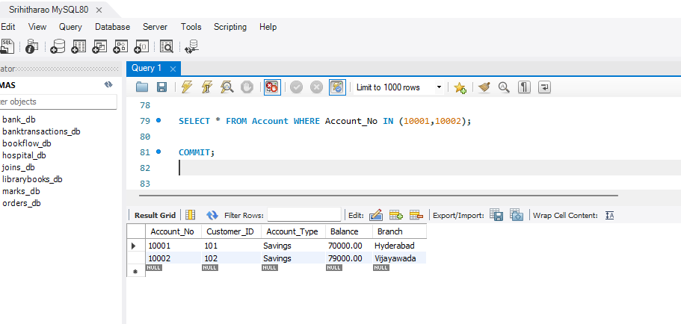

Step 9 Check Current Transaction Isolation Level
SELECT @@SESSION.transaction_isolation;

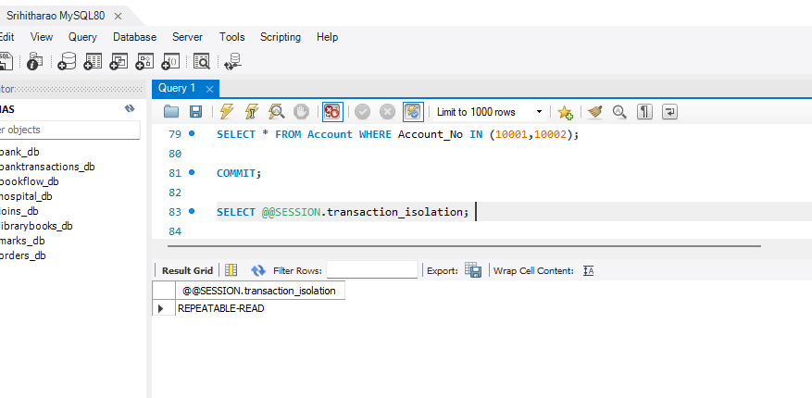

Step 10 — Change Isolation Level to READ COMMITTED
SET SESSION TRANSACTION ISOLATION LEVEL READ COMMITTED;

START TRANSACTION;

SELECT * FROM Account WHERE Account_No = 10001;

COMMIT;

